User Guide for Pythonic Data-Analyzer

Table of Contents

1. Installation 1

2. J-V 4

3. Cellevolcheck 6

4. EQE 7

5. TMM 8

6. CMM 8

7. Photospectrometry 9

8. Ellipsometry 9

9. QSSPC 9

10. Hall effect 9

11. PL 9

12. Database 10

# Installation

Install anaconda 3: [**https://www.anaconda.com/download/**](https://www.anaconda.com/download/), choose Python 3.6. During installation, choose add anaconda to my PATH environment variable (so that you can easily later use “pip install…”)   
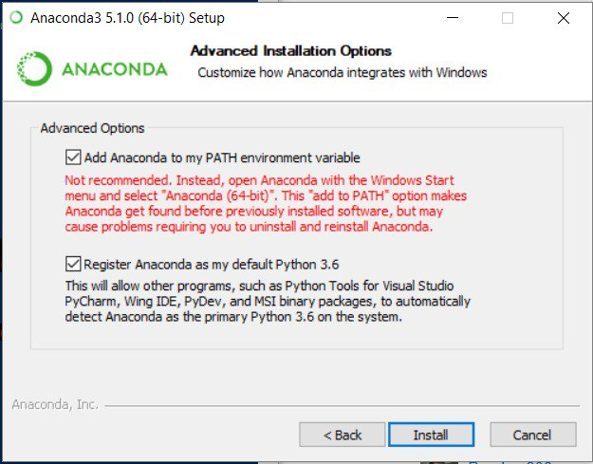

Pip install commands:

Once anaconda is installed, open a command prompt window (menu, search “cmd”)  
write the following commands:   
pip install tmm  
pip install pathlib  
pip install dill

There might be some more depending on what was or wasn’t already on your system. the easiest is to open the main file with spyder, run it and it will produce some exceptions, which will tell you that a package is missing. Then go back to the command prompt and type “pip install thenameofthepackage”

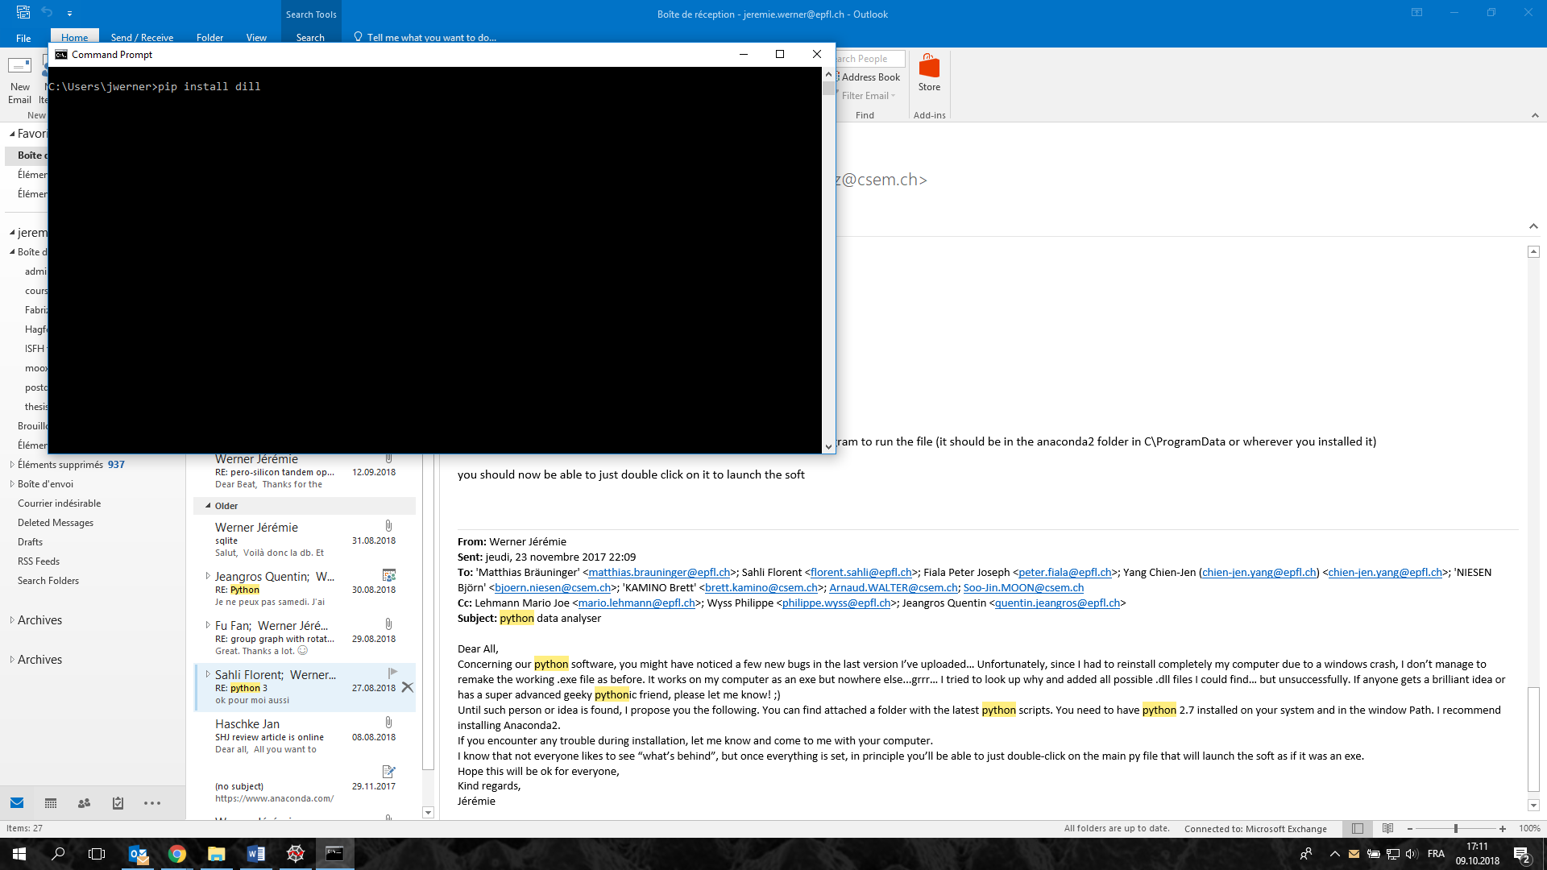

Install gitkraken: <https://www.gitkraken.com/>   
when you open this program, you should see this:

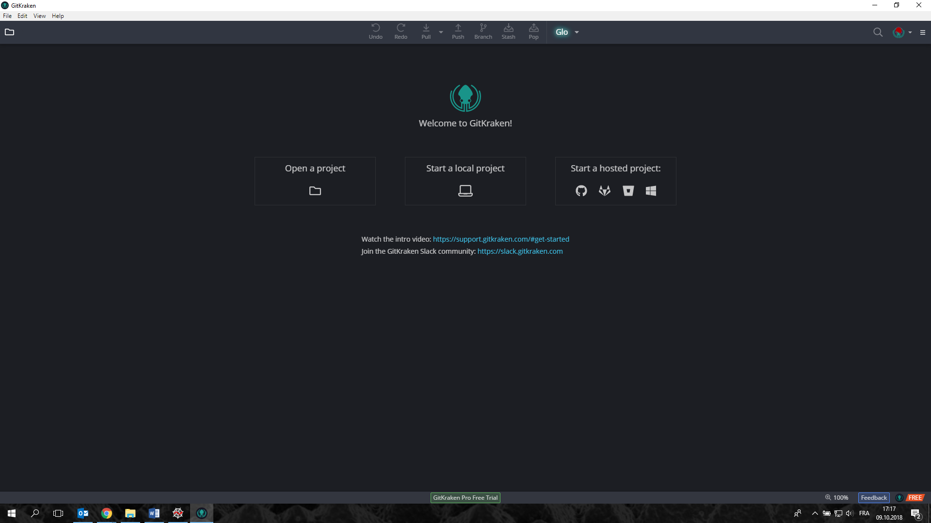

To do only the first time:

* File -> clone repo  
  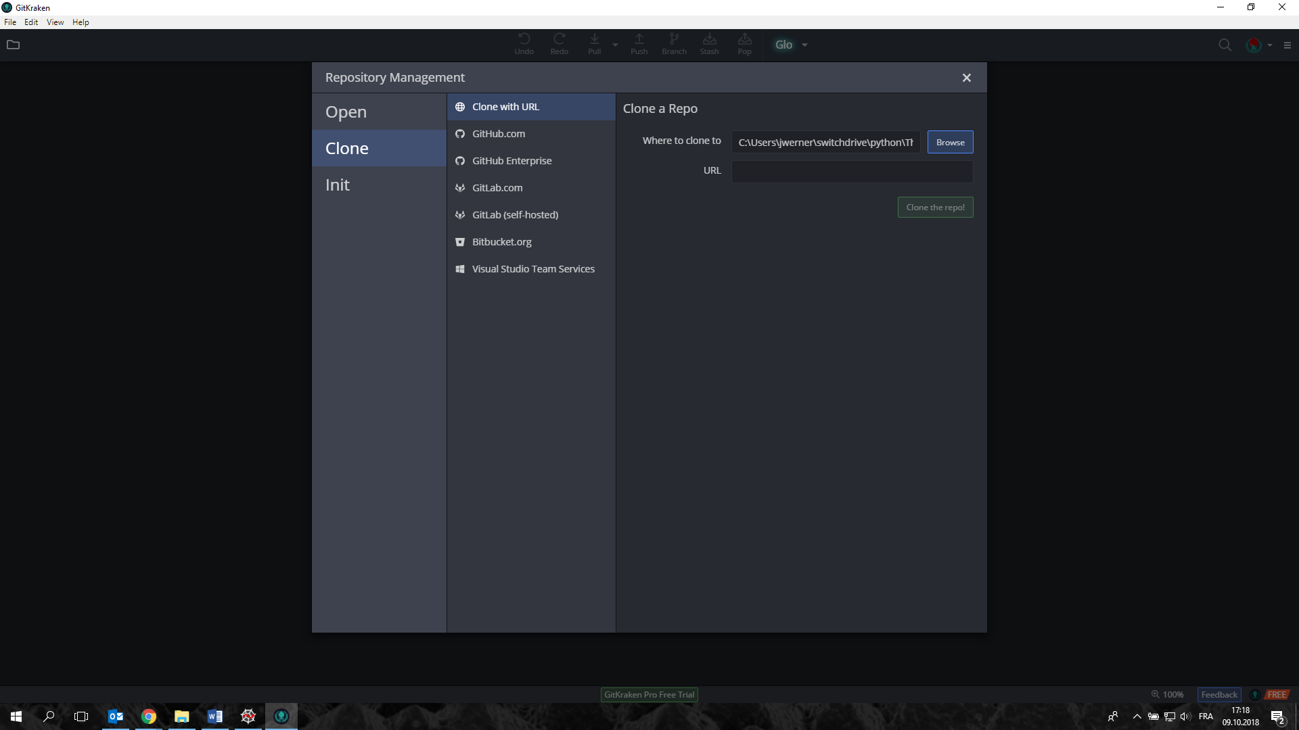   
  Clone with URL: <https://github.com/labopvlab/PythonDataAnalyzer.git> => clone.  
  this will download everything that is in the git folder to your local selected folder

If you want to modify the code and participate to its development, then you need to create a github account and then ask to become a collaborator in the labopvlab repository.

From gitkraken, it is possible to update your local code to the latest version of the master code on github just by using the Pull button.

If you modify something in the local code that you want to share and upload to the master code, you need to “stage the changes” (on the right side of the screen), then write a description of the commit (bottom right side) and commit. Then click push. You need then to log with your github account (you need to be registered as a collaborator in the labopvlab repository)

In order to use the software, you can double-click on “THEANALYSER_pyth36.py” (python needs to be in the PATH environment) or open it from spyder:

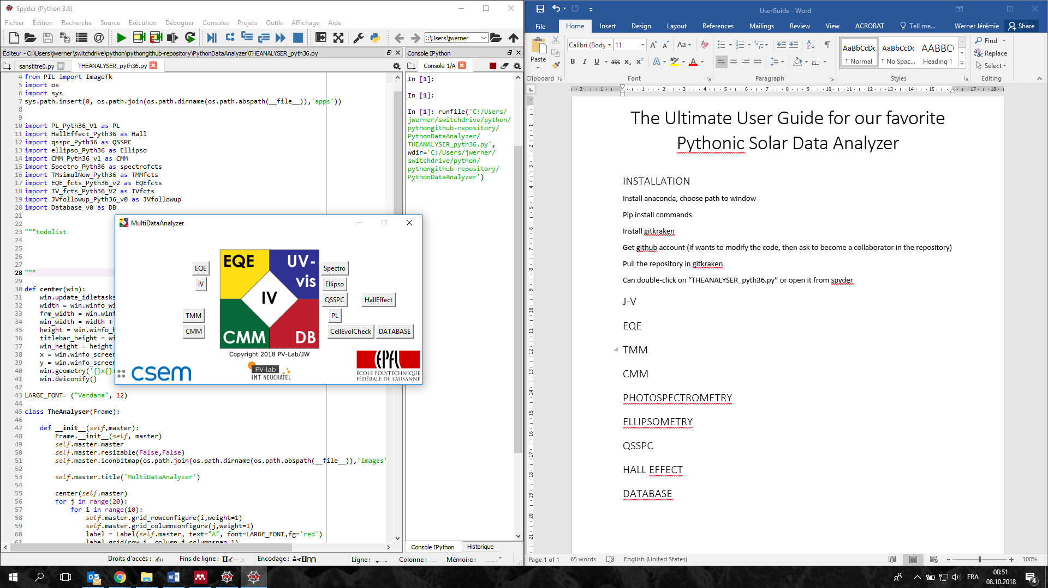

# J-V

Click on IV button from the main window.

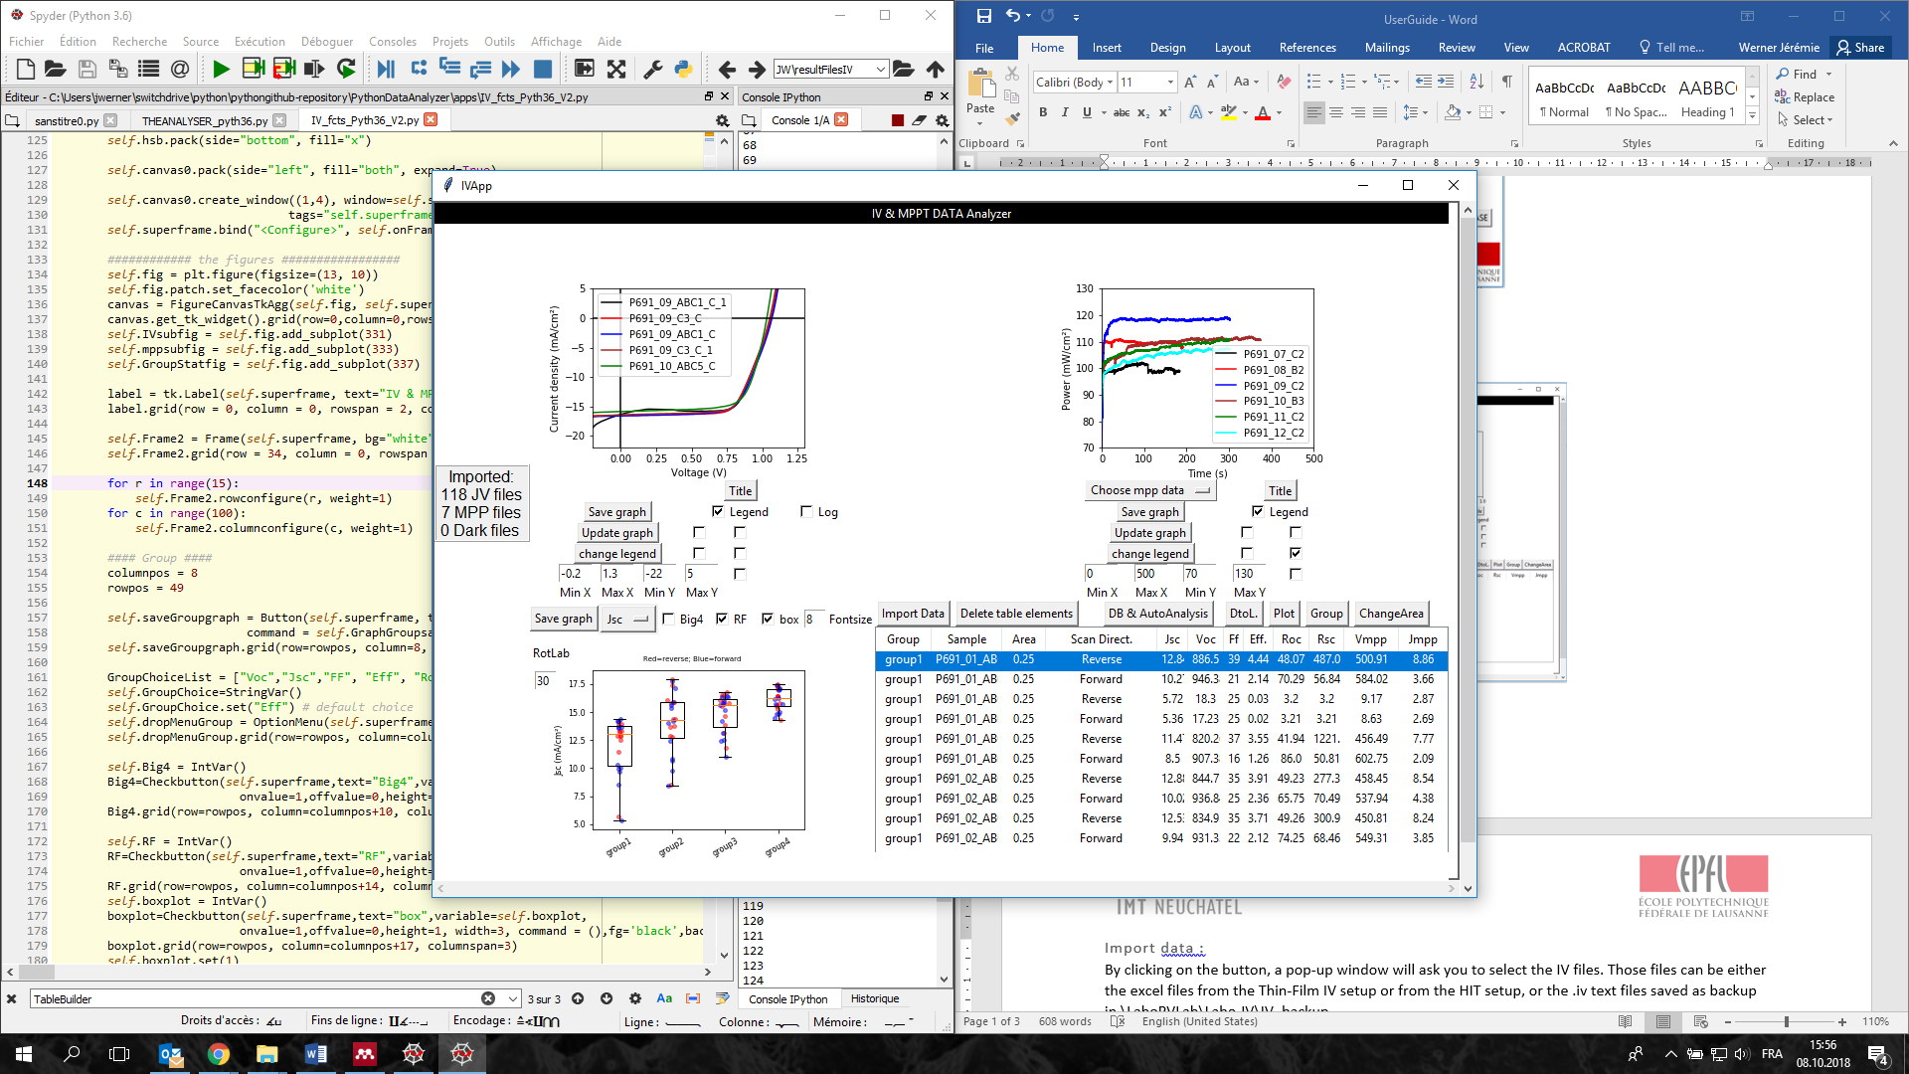

Import data :   
By clicking on the button, a pop-up window will ask you to select the IV files. Those files can be either the excel files from the Thin-Film IV setup or from the HIT setup, or the .iv text files saved as backup in \LaboPVLab\Labo-IV\IV_backup

Delete elements :

Select samples from the table (shift/ctrl-select works). Click on Delete button. BE CAREFULL: it will not ask you for confirmation. Once click the sample data is gone!

ChangeArea:

This is meant to change the cell area, if it was not set correctly during the JV measurement. It creates a window with three columns: sample name, cell area (entry to be modified), Jsc value  
it will change the cell area, the jsc value and recalculate the eff, change the J-V data in the jv curves and also correct the rawdata txt file on the server.

DtoL:

If you selected the low illumination option in the thin-film iv software but it was actually a full illumination, then you can modify this here. BE CAREFULL: this is to be done before importing the data in the app.   
once DtoL clicked, it opens a window with a table. Select the samples to be changed and click change dark to light. It will change also the rawdata .iv files.

Plot:

Select samples from the table (shift/ctrl-select works). Click on Plot button. Then click on the “Update graph” button under the IV graph, which should display the curves.

JV graph:

Legend can be displayed, in 5 different positions (tick boxes). If legend is checked, the legends can be modified (change legend button): new names, line style and color. Choose what you want and click update. Reorder button opens a pop-up window with a listbox where you can drag the samples in the desired order.   
“title” button allows you to add a title at the top of the graph. Save graph… well… saves the graph.

Group:

Select samples from the table (shift/ctrl-select works). Click on Group button.

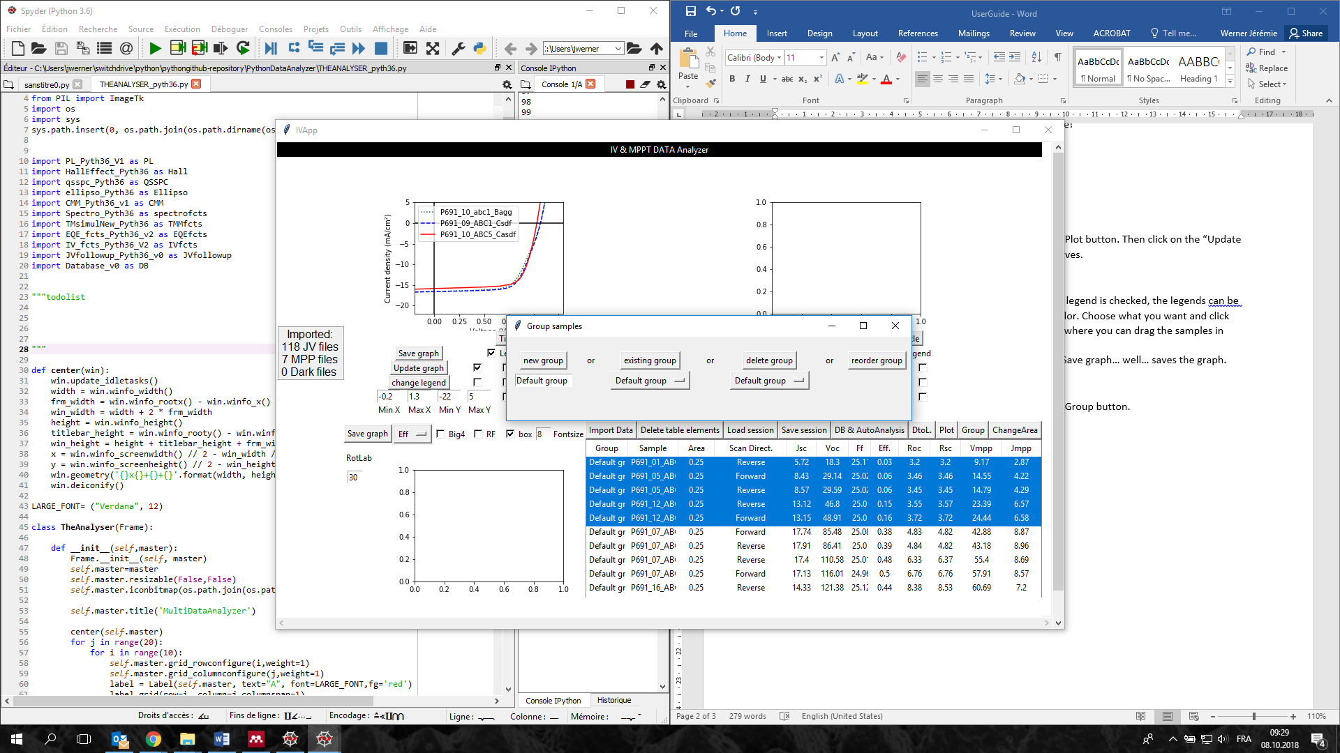

You can either add the selected samples to a new group or to an existing group.   
delete group: select the group name you want to delete. It will put back to “Default group” all samples that were in the selected group.   
reorder group allows you to have a different order of the group names, as they will appear in the group graph

Group graph:

Once you have created group(s) in your data, you can see them in the group graph by selecting a parameter (e.g. Voc, Jsc…). By default, it will create a boxplot graph. You can remove the box by unchecking the box (…). This will leave you with only the data points (red for reverse (VoctoJsc) scans, blue for forward (JsctoVoc) scans.   
If you tick the “RF”, it will restrain the data to only the best forward-reverse scans for every cell (to avoid statistical visual bias by an over-measured good cell)  
the graph can be saved with the “save graph” button. If the “Big4” is ticked, it will save directly the graphs of Voc, Jsc, FF and Eff.

Mpp graph:

Similar to the JV graph, except that you select the mpp data from the drop-down list (“Choose mpp data”).

DB & AutoAnalysis:

Three options:

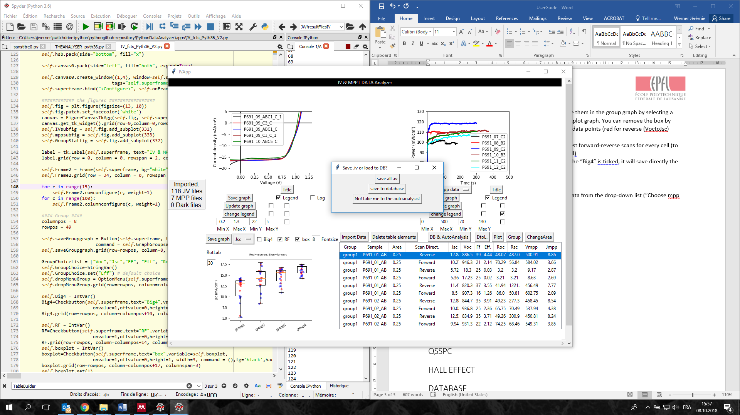

* Save all .iv files to a folder, to use them later typically in the CellEvolCheck app
* Save to database: use this option only if you already prepare a db with the batch/samples information. it will ask to select an sqlite .db file, and then it will try to find the entry corresponding to the batch name, sample name, and cell name. those information need to be exactly the same in the database as in the IV files
* Direct to autoanalysis:   
  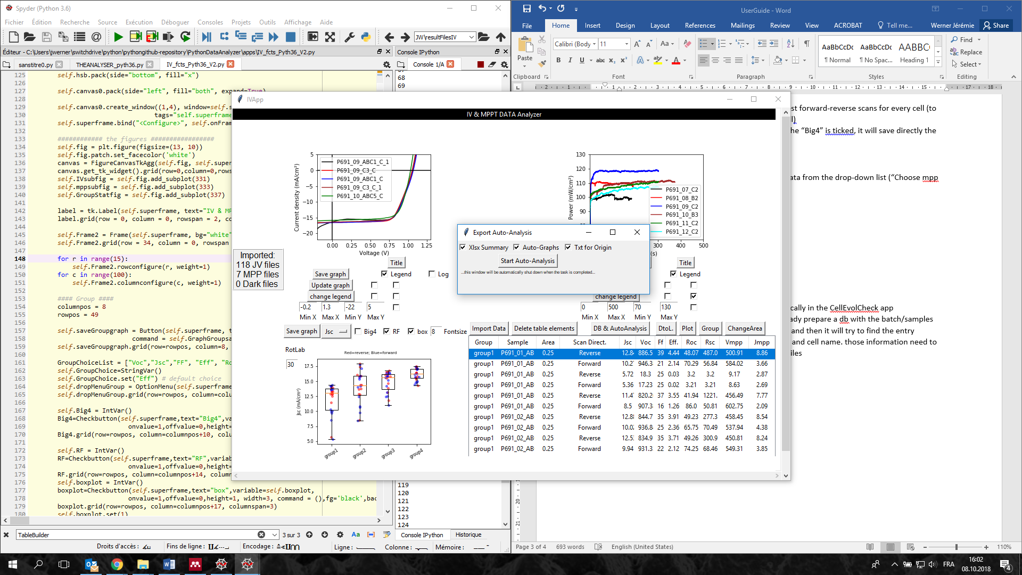  
  this app will analyze your data automatically, sort the measurements by substrates, meas type… create graphs with JV curves by substrates, some graphs with statistics/trends/groups… txt files with data ready for origin…

# Cellevolcheck

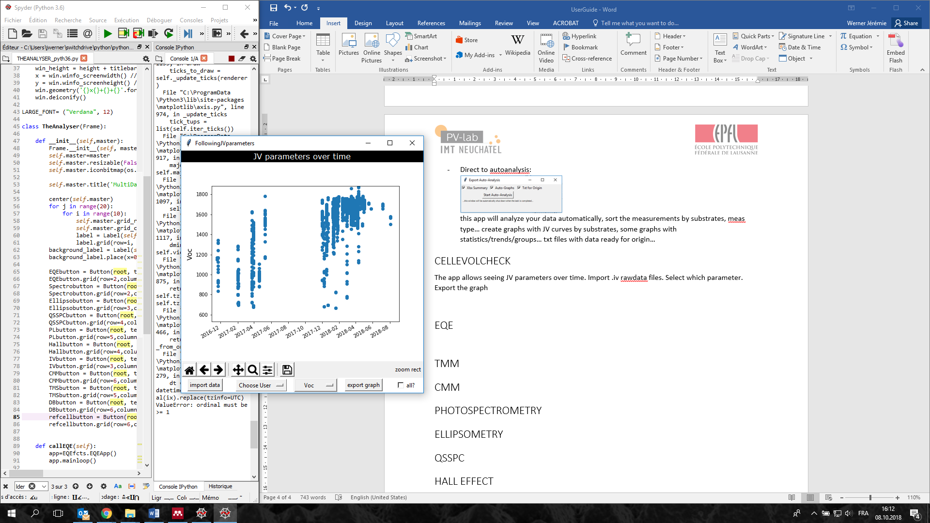

The app allows seeing JV parameters over time. Import .iv rawdata files. Select which parameter. Export the graph. The data can be restricted to one or more specific users.

# EQE

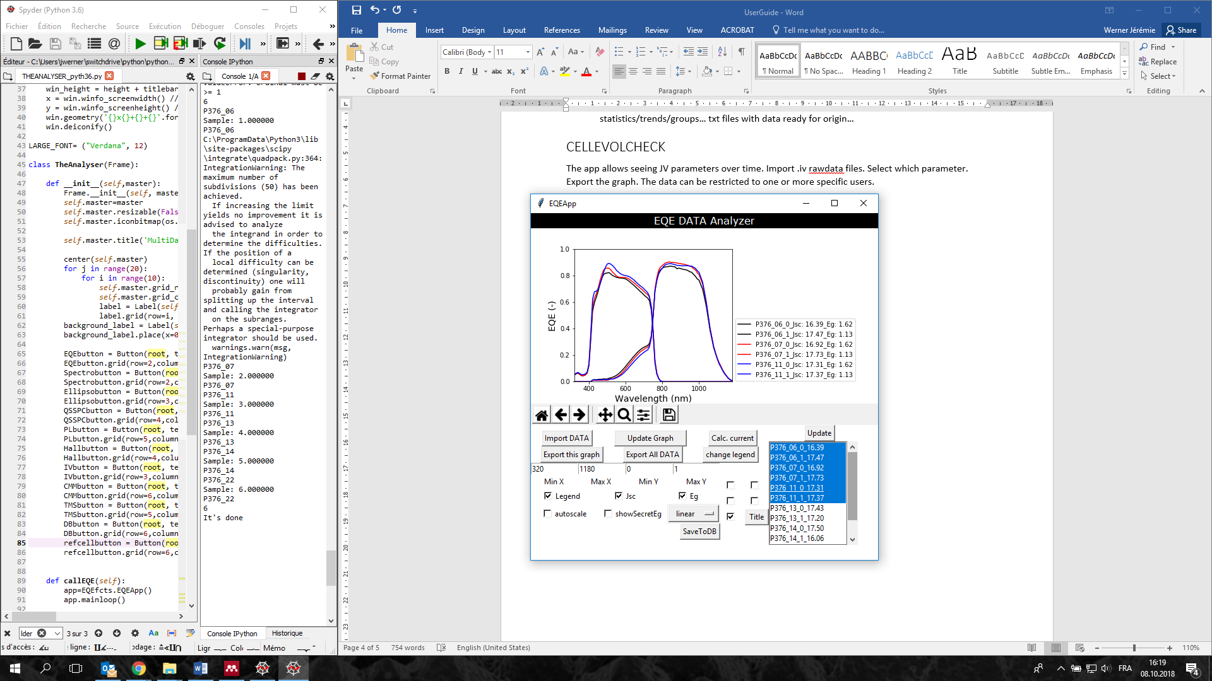

This app allows to analyze EQE excel files (pvlab ones). Start by importing the data (select the excel files).

* If you want to plot the “total Jsc vs wavelength” curve, say yes on the pop up window when importing files. Be aware that this slows down drastically the importation as it has to do plenty of integrals… but then can plot this curve on top of the eqe curves. You can skip this by saying no.
* Export All DATA: if in a hurry, this button will generate automatically graphs and txt files for all EQE curves and an excel file summarizing the Jsc, Eg for all meas.
* Plotting: select the samples in the listbox, click update button
* showSecretEg: shows you the lines which served at finding the Eg, to verify the fit looks correct.
* Change legend: to modify the legend names, color…
* Drop down list to change to linear, log, tauc, normalization… and use the autoscale to get the curves directly visible
* Calc. current: allows to calculate current of a sample in a specific wavelength range. Select sample in drop down list, enter the range, click calculate
* SaveToDB: saves the EQE data to the database. Same as for the JV, the batch/samples need to be already present in the database.

# TMM

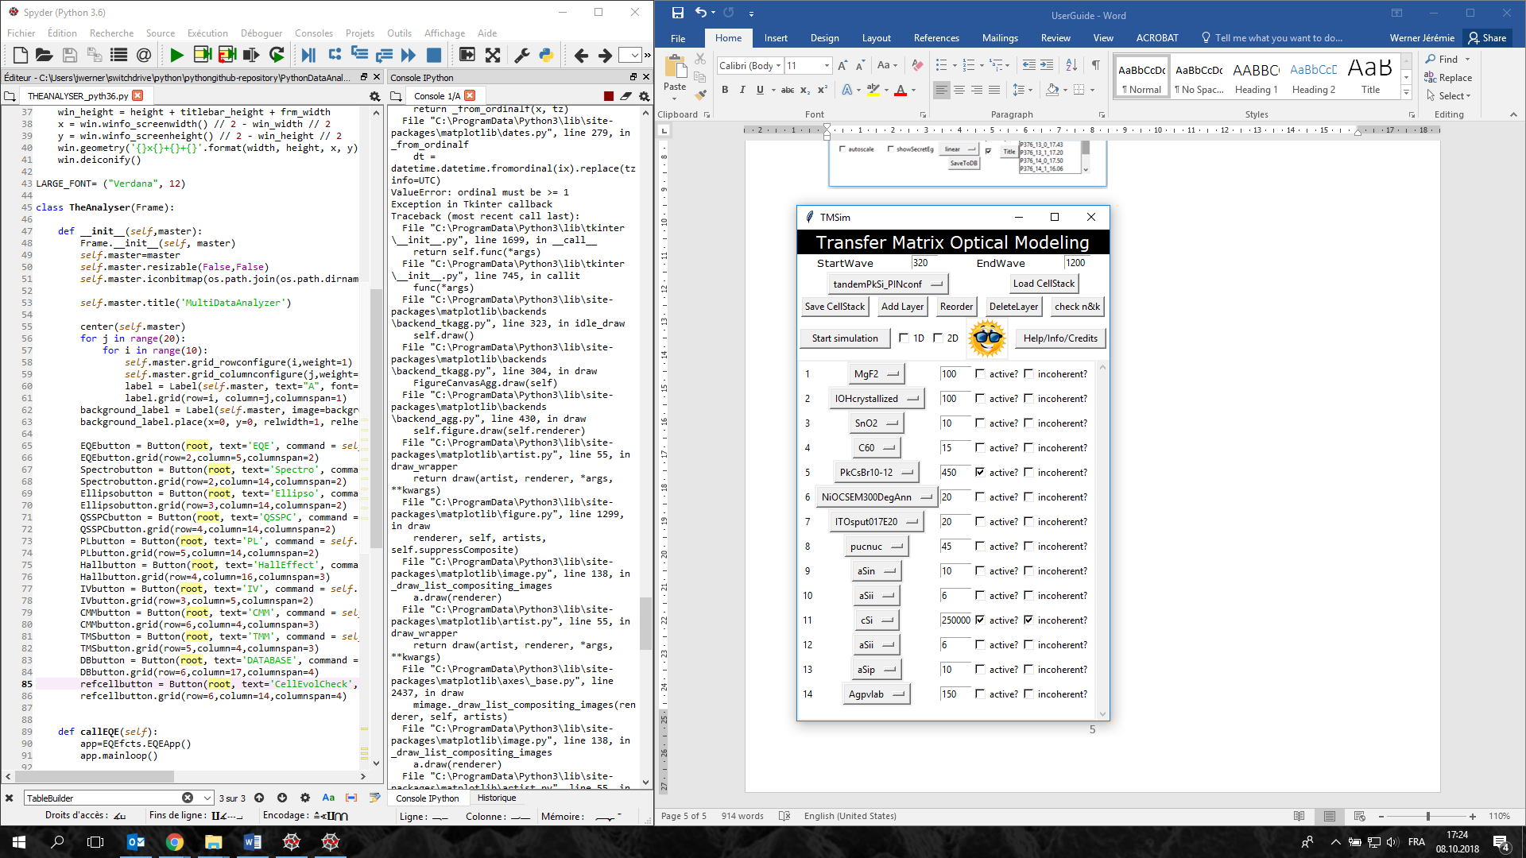

* StartWave and EndWave: gives the wavelength range over which the simulation are runned
* Load CellStack: select a predefined stack in the drop-down list
* Save CellStack: saves a new cell stack that can be reloaded later from the dropdown list above. (only after restarting the app. The files in the folder TMstacks are loaded at the start of the app)
* Addlayer, reorder, deletelayer: … well… obvious I guess.  
  to be defined for each layer: its material (from the drop down list), its thickness (in nm), if it’s an active absorber layer, if it should be taken as coherent or incoherent.
* Check n&k: allows to see the n&k data plotted in order to judge by yourself of its quality.
* Start simulation: calculates the absorption of all layers and creates a graph with the EQE-like curves of the active layers
* 1D, 2D: check before click on start simulation. Do the normal simulation first, then put a window where you can choose a layer and thickness range to vary. Creates a graph with the current(s) of the absorber layer(s) as function of the thickness varied in the sweep.

# CMM

Link to website in shiny from Jean Catin and Olivier Dupré. File preparation for the sweeps in the CellTester. Analysis of the files to get the graphs in function of spectrum.

(not fully developed, due to limited number of user => check with Olivier/Florent for more info on CMM)

# Photospectrometry

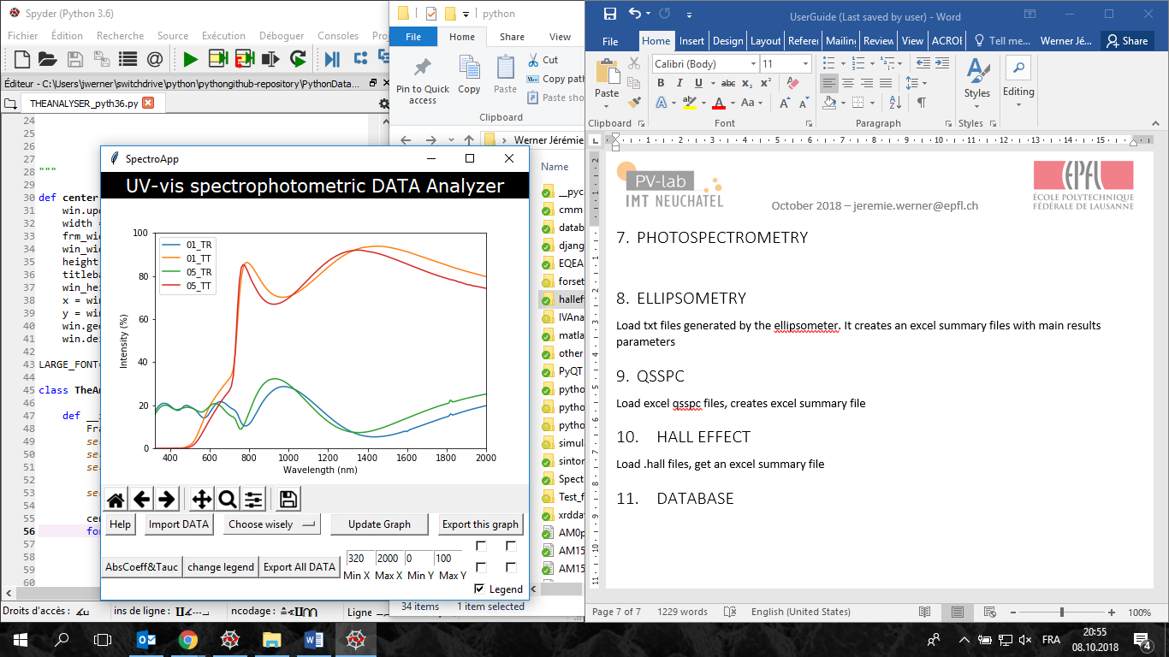

* File type: please check the Help in the app
* BE CAREFULL: the samples need to be named properly (see help) otherwise the app cannot recognize which samples are linked
* Export All DATA: creates files ready for origin

# Ellipsometry

Load txt files generated by the ellipsometer. It creates an excel summary files with main results parameters

# QSSPC

Load excel qsspc files, creates excel summary file

# Hall effect

Load .hall files, get an excel summary file

# PL

* load the PL baseline excel files
* select a folder to save the results
* select the csv files with pl data
* it generates txt files and graphs, with peak fits to find its position (summarized in a separate file). PL over time: csv file containing “Frames” to txt files for easy plots (generates also automatically a peak-evolution graph which calculates the area under the curves for all frames (so time evolution of peak)

# XRD

Autoanalysis of XRD patterns.

Load the files

Select a folder to save the results

Done!

It creates graphs and txt files with the peaks automatically found and analysed (position, height, FWHM), which you can see the details in the created excel file

# Database

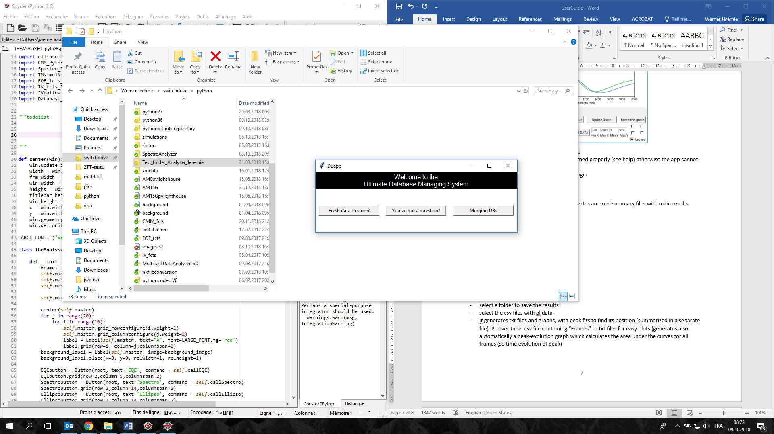

This app allows the creation of a sqlite3 local database, fill the database with batch and sample structure information, and later on extract information according to user-defined criteria.

IMPORTANT: you need to start by creating a database and loading batch/samples information from this app. Then only it is possible to load IV and EQE data from their respective apps.

* Fresh data to store:   
  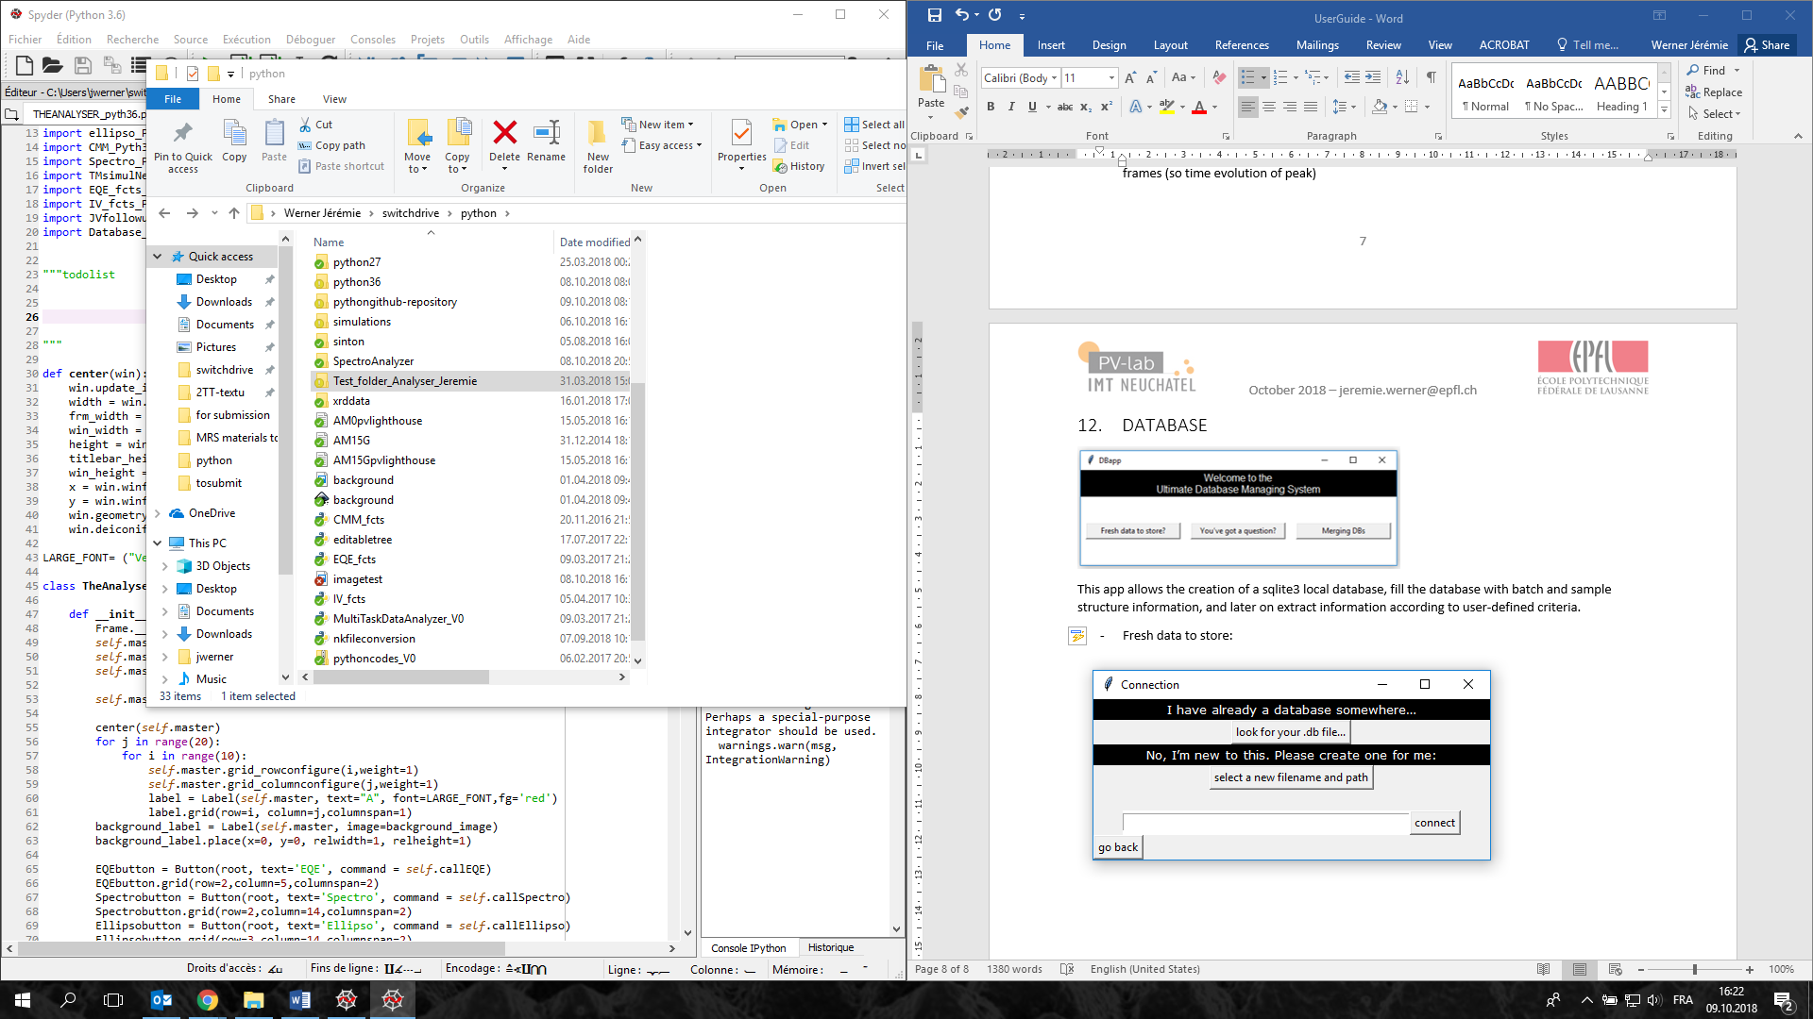  
  either a .db file was already created before and it can be reloaded, or we need to create a new one (select a new filename and path). Once this is done, click connect.
* New batch?   
  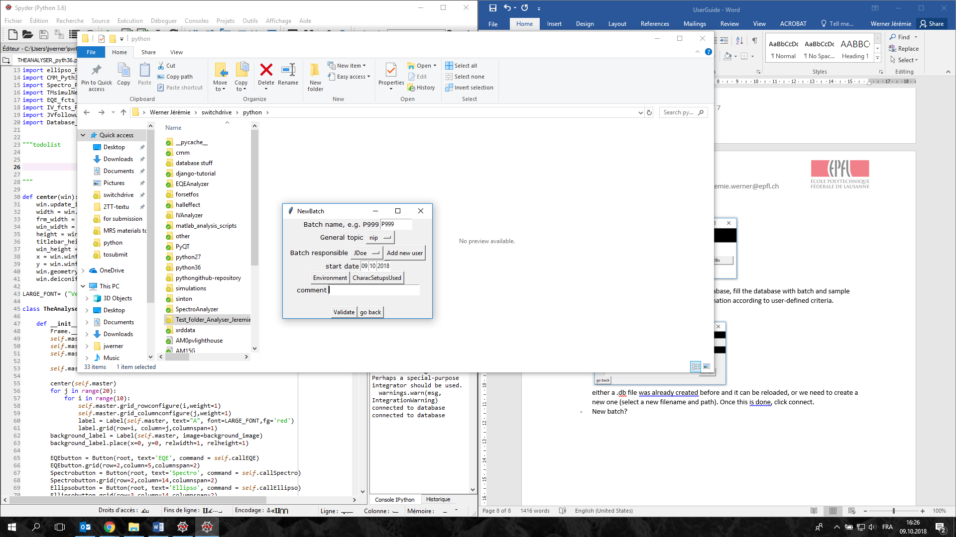  
  fill the batchname entry, the general topic, choose a batch responsible name, you need to enter environmental data and characsetups (if no data, just open and validate the default)
* Create samples: each sample must have a different number (it has to be strictly the same as you will use during JV&EQE measurements!);   
  small trick: the <enter> key is linked to the button “Add new sample”  
  if “triple” is selected as general topic, then the sample window will be adapted as seen here:  
  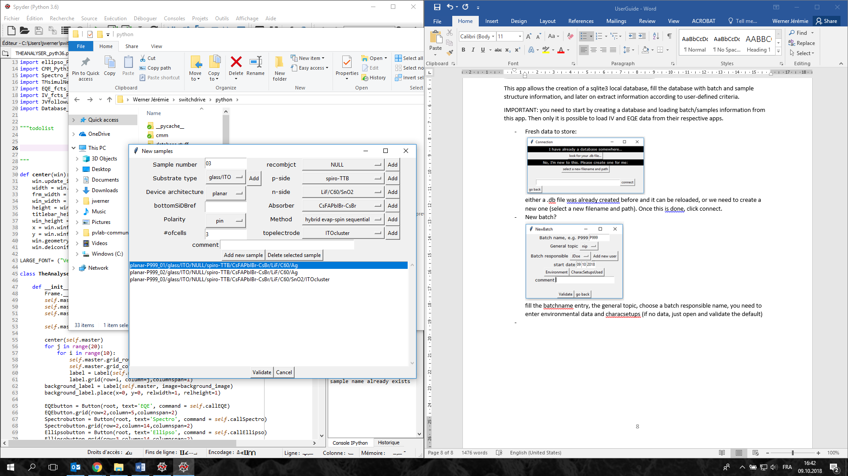   
  if triple:  
  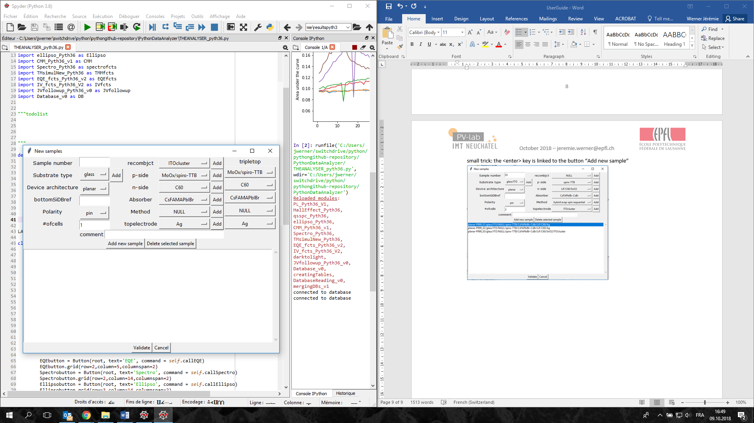  
  click validate to finish the process. It is now ready to be used in the JV and EQE apps to associate and store data in this .db file.
* If several people want to share their database, it is possible by using the merging option.   
  first select the main database (the one that will receive all data)  
  then select the second database to be merged. (this one will be kept unchanged)